Lab 2 Placeholder

I created a repository for the Architectures, Operating Systems and The Cloud Module
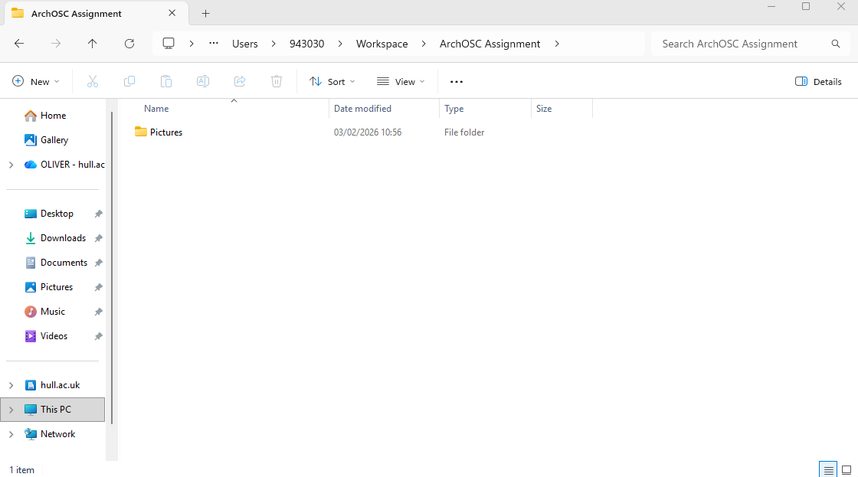
I created a Workspace folder and have taken a screenshot of said folder whilst ensuring to give all files clear naming conventions.
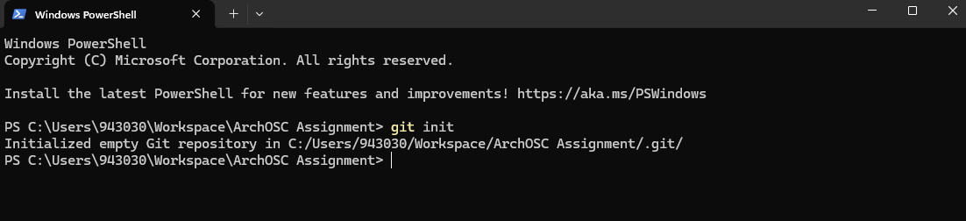
Used the “Open in terminal” function via right clicking on my project folder to open the command line straight to this location. I also used the “git init” command to make an empty git repository in this location.
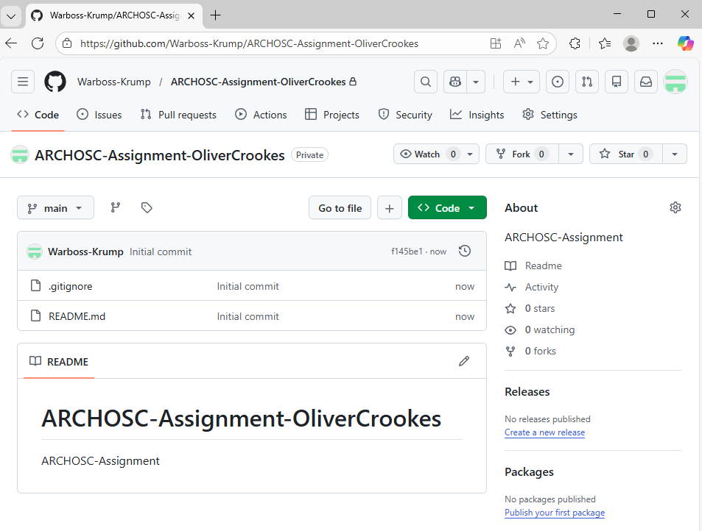
Created a new repository for the ARCHOSC Assignment within Github.
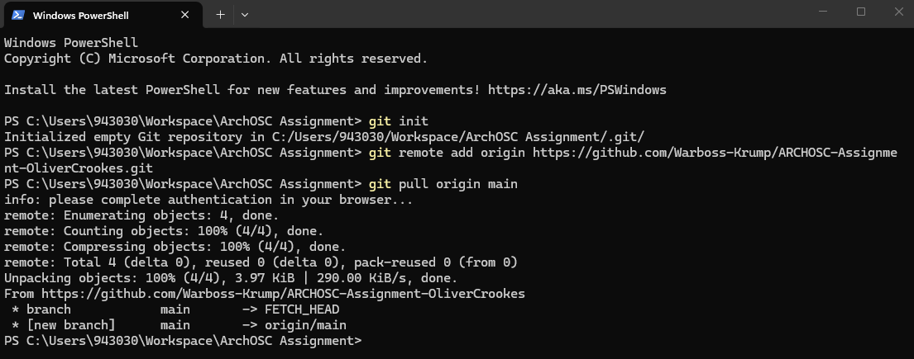
Used the “git remote add origin” command and the “git pull origin main” command to link my repository to github.
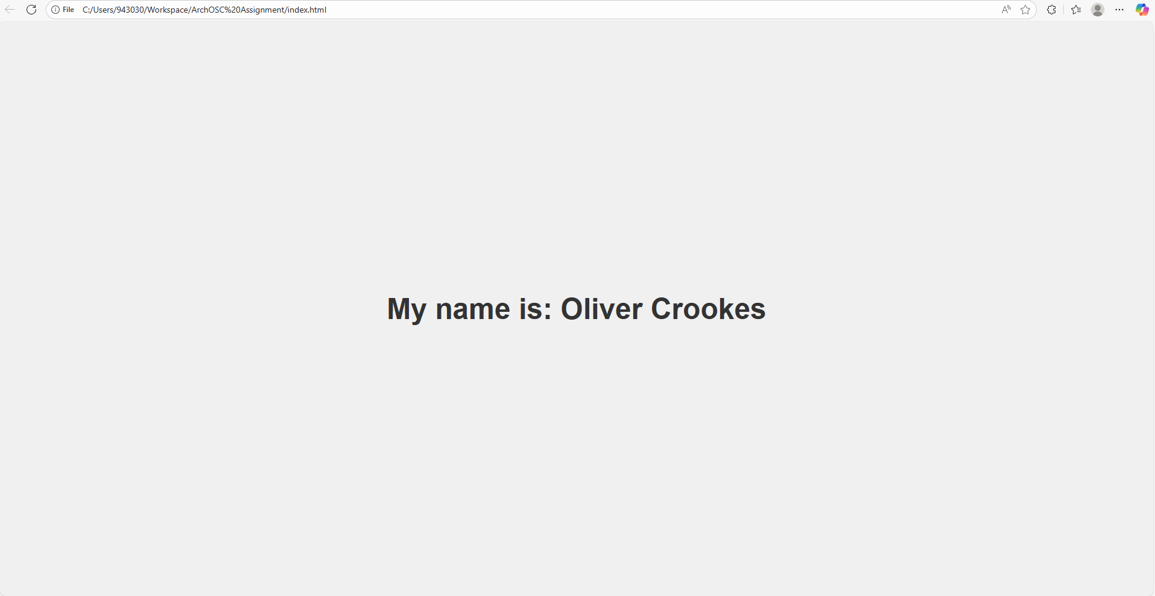
I created a new website in Visual Studio Code and edited it to state my name.

